**Assignment 3**

1. Which function is responsible for starting the program?(1 mark)

1. runApp()
2. mainApp()
3. main()
4. flutter()

2. Choose the one of the looping of Dart?(1 mark)

1. Flutter loop
2. For in Loop
3. Do While Loop

3. Write down all of loops of Dart? (2 marks)

4. Write a program to print out the value from 1 to 20 using “ For Loop”? (4 marks)

5. Write a program to print out the value from 1 to 100 using “while Loop”? (4 marks)

6. The variable called “num” has value 10. (int num = 10) Display Sum of (num) Numbers Using While Loop.(6 marks)

7. Choose One of the decision making in Dart?(1 mark)

1. for (item in object)
2. If … else
3. Not if .. else

8. Which decision making has “break;” ?(1 mark)

1. If--else
2. switch -case

9. How to understand if-else statements in Dart? (2 marks)

10. We take an integer value in x, and check if the number in x is even or odd using an if-else statement. (Hint : x%2==0 to get even number) (4 marks)

11. Guess what is your grade according to the following codes( 1 mark )

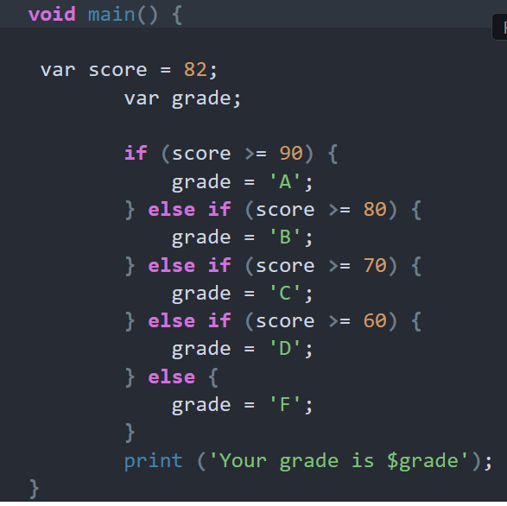

12.There are 5 levels in Dart class. They are :

1. Beginner Level(B)
2. Entry Level (E)
3. Pre-Intermediate (PI)
4. Intermediate (I)
5. Advanced (A).

Write a program to determine the level of dart class by using switch-case. (3 marks)